30. Develop a system using UML for the Train ticket Reservation System. The customer can create a login and the details are stored by the system. The customer can view the train and seat availability from source to destination on a given date and time. The customer can book tickets and view the status of the train. The customer can cancel the ticket and a refund will be decided based on the time remaining before the departure of the bus.

**Activity Diagram :**

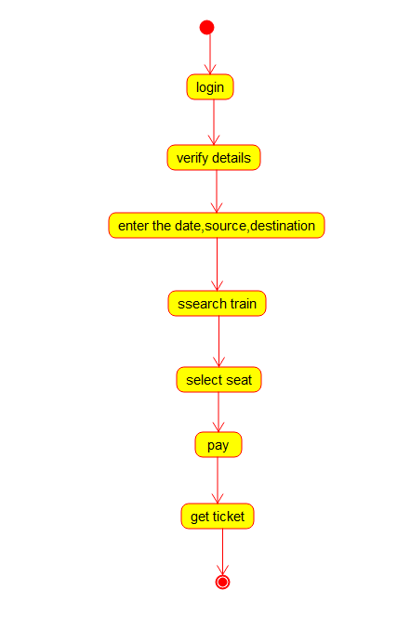

**Class Digram :**

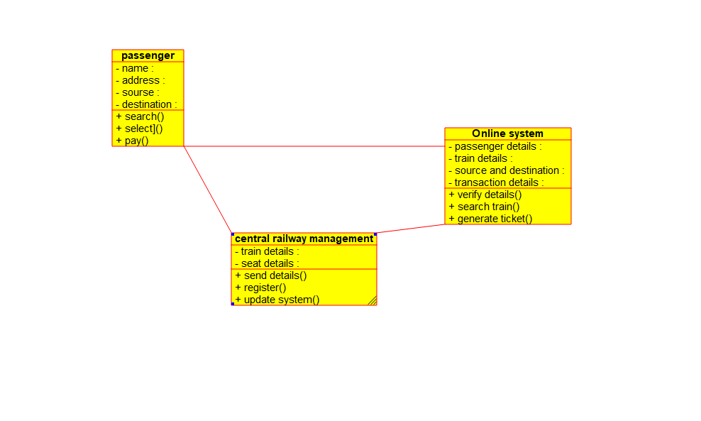

**Use Case Diagram :**

